**A**

## Minor Project

## [IoT BASED HOME DESIGN WITH MOTION &FIRE DETECTOR]

**BY**

**Mani Sharma**

**(0221BCA060)**

**Aman Kumar**

**(0221BCA045)**

**Vansh Jain**

**(0221BCA041)**

**Aarohi Maddeshiya**

**(0221BCA105)**

**Sneha Singh**

**(0221BCA037)**



**Under the supervision of**

**Asst.Prof. Saurabh Singh**

**FACULTY OF IT DEPARTMENT,**

**DOON BUSINESS SCHOOL(DEHRADUN)**

**CANDIDATE’S DECLARATION**

We hereby declare that the mini project work being presented in this report entitled “**IoT Based Home Design With Motion &Fire Detector”** submitted in the department of computer application, FACULTY OF TECHNOLOGY, *Doon business school, Dehradun* is the authentic work carried out us under the guidance of **ASST.PROF. SAURABH SINGH**, Professor, Department of computer application, *Doon business school, Dehradun.*

Date: 15/12/2023 Mani Sharma

Aman Kumar

Vansh Jain

Aarohi Madhesiya

Sneha Singh

B.C.A-2nd Year

**ACKNOWLEDGEMENT**

We would like to express my special thanks of gratitude to my teacher **ASST.PROF. SAURABH SINGH** who gave us the golden opportunity to do this wonderful project **“ IoT BASED HOME DESIGN WITH MOTION & FIRE DETECTOR”** which also helped us doing a lot of research and we came to know about so many new things. We are really thankful to them.

Date: 15/12/2023 Mani Sharma (0221BCA060)

Aman Kumar (0221BCA081)

Vansh Jain (0221BCA041)

Aarohi (0221BCA0105)

Sneha Singh(0221BCA037)

B.C.A 2nd year

Doon Business School,Dehradun

**SYNOPSIS**

IoT Based Home Design With Motion &Fire Detector

1. **IoT (Internet of Things):-** It refers to the collective network of connected devices and the technology that facilitates communication between devices and the cloud, as well as between the devices themselves. Thanks to the advent of inexpensive computer chips and high bandwidth telecommunication, we now have billions of devices connected to the internet. This means everyday devices like toothbrushes, vacuums, cars, and machines can use sensors to collect data and respond intelligently to users.

**Features of IOT­:-**

* Intelligence
* Connectivity
* Dynamic Nature
* Sensing
* Security

**Advantages of IoT:-**

* Efficient and Saves Time
* Automation of daily tasks leads to better monitoring of devices
* Better Quality of Life

**Disadvantage of Iot:-**

* Technology Takes Control of Life
* Privacy/Security
* Privacy/Security

1. **IoT Based Home Design:-** The [**concept of Home Automation**](https://smartify.in/knowledgebase/home-automation-details/) aims to bring the control of operating your everyday home electrical appliances to the tip of your finger, thus giving user affordable lighting solutions, better energy conservation with optimum use of energy. Apart from just lighting solutions, the concept also further extends to have a overall control over your home security as well as build a centralized home entertainment system and much more.
2. The IoT based Home Automation system offer a lot of flexibility over the wired systems s it comes with various advantages like ease-of-use, ease-of-installation, avoid complexity of running through wires or loose electrical connections, easy fault detection and triggering and above and all it even offers easy mobility.
3. **Motion Detector:-** A **motion detector** is an electrical device that utilizes a [sensor](https://en.wikipedia.org/wiki/Sensor) to detect nearby [motion](https://en.wikipedia.org/wiki/Motion). Such a device is often integrated as a [component](https://en.wikipedia.org/wiki/Electronic_component) of a system that automatically performs a task or [alerts a user](https://en.wikipedia.org/wiki/Security_alarm) of motion in an area. They form a vital component of security, [automated lighting control](https://en.wikipedia.org/wiki/Lighting_control_system), home control, [energy efficiency](https://en.wikipedia.org/wiki/Efficient_energy_use), and other useful systems.
4. A motion detector may be among the sensors of a [burglar alarm](https://en.wikipedia.org/wiki/Security_alarm) that is used to alert the home owner or security service when it detects the motion of a possible intruder. Such a detector may also trigger a [security camera](https://en.wikipedia.org/wiki/Security_camera) to record the possible intrusion.
5. **Fire /Smoke Detector:-** A **smoke detector** is a device that senses [smoke](https://en.wikipedia.org/wiki/Smoke), typically as an indicator of [fire](https://en.wikipedia.org/wiki/Fire). Household smoke detectors, also known as *smoke alarms*, generally issue an audible or visual [alarm](https://en.wikipedia.org/wiki/Alarm) from the detector itself or several detectors if there are multiple devices interlinked. Household smoke detectors range from individual battery-powered units to several interlinked units with battery backup. With interlinked units, if any unit detects smoke, alarms will trigger at all of the units.

**OBJECTIVE OF THE PROJECT:**

1. **Design of an independent HAS:**

To formulate the design of an interconnected network of home appliance to be integrated into the HAS. The objective to account for every appliance and its control to be automated and integrated into the network further formulated into the HAS(House Automation System).

1. **Wireless control of home appliances (Switch and Voice mode):**

To develop the application that would include features of switch and/or voice modes to control the applications.

1. **Monitoring status of appliances:**

Being able to view the status of home appliances on the application, in order have a better HAS

1. **Controlled by any device capable of Wi-Fi (Android, iOS, PC):**

To achieve flexibility in control of the home appliances, and device capable of Wi-Fi connectivity will be able to obtain a secure control on the HAS

1. **Extensible platform for future enhancement:**

With a strong existing possibility of adding and integrating more features and appliances to the system, the designed system needs to be highly extensible in nature.

1. **Secure connection channels between application**:

Use of secure protocols over Wi-Fi so that other devices are prevented to achieve control over the HAS.

**SCOPE**

The system can be implemented in homes, small offices and malls as well, being in-charge of control of the electrical appliances. For remote access of appliances in internet or intranet. The appliances in the above mentioned environment can be controlled in intra-network or can be accessed via internet. The development of technology friendly environment.

The system incorporates the use of technology and making HAS. By the use of day to day gadgets we can utilize them for a different perspective.

**OVERVIEW AND BENEFITS**

The benefits of an established wireless remote switching system of home appliances include:

1. **Reduced wiring issues-**Considering the increase in price of copper, thus increases the possibility of the wire to be stolen. The use of a wireless remote system to control home appliances means no wire for thieves to steal.
2. **Extended range-** As the system establishes control over Wi-Fi, it was a generally considered descent range. That is 150 feet indoors. Outdoors it can be extended to 300 feet, but since the application is of a HAS, an indoor range is considered.
3. **Security** -As the connection of the control of the HAS is established over a secure network the system ensures security to the maximum extent.

1. **Integrable and extensive nature-** The prototype designed can be integrated to a larger scale. Also it has an extensive nature being able to add or remove the appliances under control according to application.

**APPLICATION AND TOOLS USED IN PROJECT**

**CISCO PACKET TRACER:-**

**Cisco Packet Tracer** as the name suggests, is a tool built by Cisco. This tool provides a network simulation to practice simple and complex networks.

***As Cisco believes, the best way to learn about networking is to do it.***

The main purpose of Cisco Packet Tracer is to help students learn the principles of networking with hands-on experience as well as develop Cisco technology specific skills. Since the protocols are implemented in software only method, this tool cannot replace the hardware Routers or Switches. Interestingly, this tool does not only include Cisco products but also many more networking devices.

Using this tool is widely encouraged as it is part of the curriculum like CCNA, CCENT where Faculties use Packet Trace to demonstrate technical concepts and networking systems. Students complete assignments using this tool, working on their own or in teams.

**Workspace :**

1. **Logical –**  
   Logical workspace shows the logical network topology of the network the user has built. It represents the placing, connecting and clustering virtual network devices.
2. **Physical –**  
   Physical workspace shows the graphical physical dimension of the logical network. It depicts the scale and placement in how network devices such as routers, switches and hosts would look in a real environment. It also provides geographical representation of networks, including multiple buildings, cities

and wiring closets.

**Key Features:**

* Unlimited devices
* E-learning
* Customize single/multi user activities
* Interactive Environment
* Visualizing Networks
* Real-time mode and Simulation mode
* Supports majority of networking protocols

**STRUCTURE OF PROJECT**

FIRST STEP TOWARDS PROJECT:-

**INSTALL CISCO PACKET TRACER**

**Step 1:**Visit the official website of [Netacad](https://www.netacad.com/" \t "_blank) using any web browser.

**Step 2:**Press the login button and select log In option.



**Step 3:**Next screen will appear, click on the sign-up option.

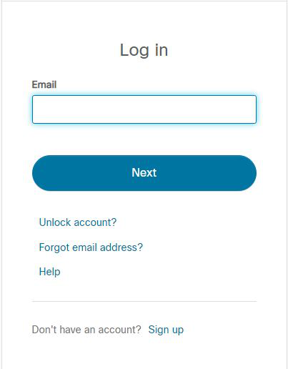

**Step 4:** Next screen will appear and will ask for email and password and other simple details, fill them and click on Register.

**Step 5:**Now the login screen appears again so fill in the Email id.

**Step 6:**On the next screen enter the password and press the Login button.

**Step 7:**Dashboard will initialize, now click on Resources and choose Download Packet Tracer Option.

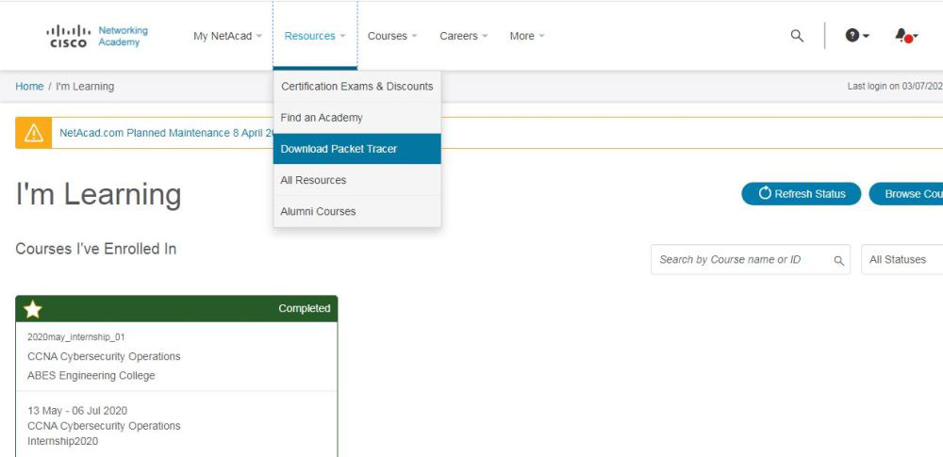

**Step 8:**On the next web page choose the operating system to download the packet tracer. Downloading will start automatically.

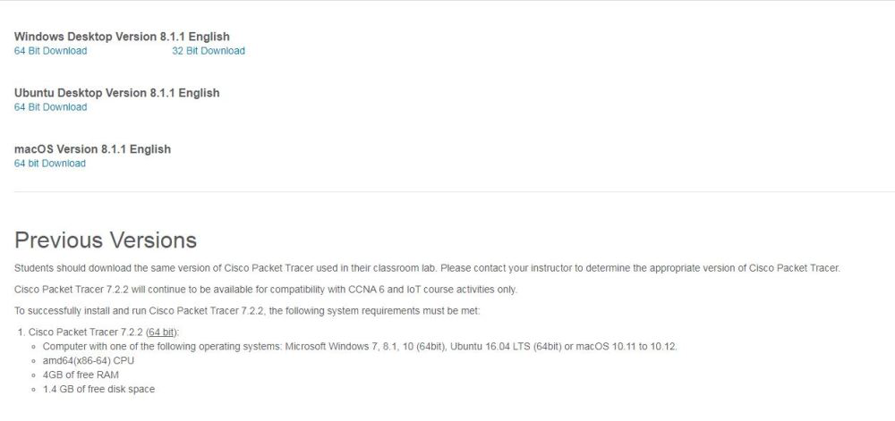

**Step 9:**Check for the executable file in your system and run it.



**Step 10:**Next screen is of License Agreement so Click on **I accept** the license.

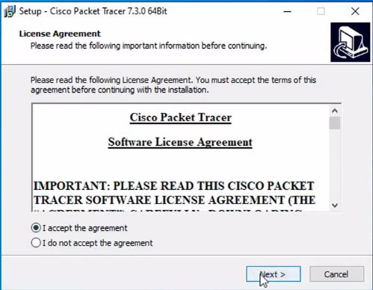

**Step 11:**Choose the installing location which has sufficient space.

**Step 12:** Select the start menu folder and click the **Next** button.

**Step 13:**Check the box for creating a desktop icon and click on the **Next** button.

**Step 14:** Now packet tracer is ready to install so click on the **Install**button.

**Step 15:**The installation process will start and will hardly take a minute.

**Step 16:**Click on the **Finish** button to complete the installation.

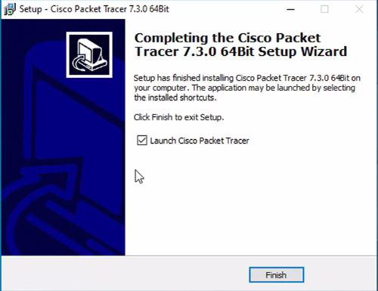

**Step 17:**An icon is created on the desktop so run it.



**Step 18:** Interface is initialized and the software is ready to use.

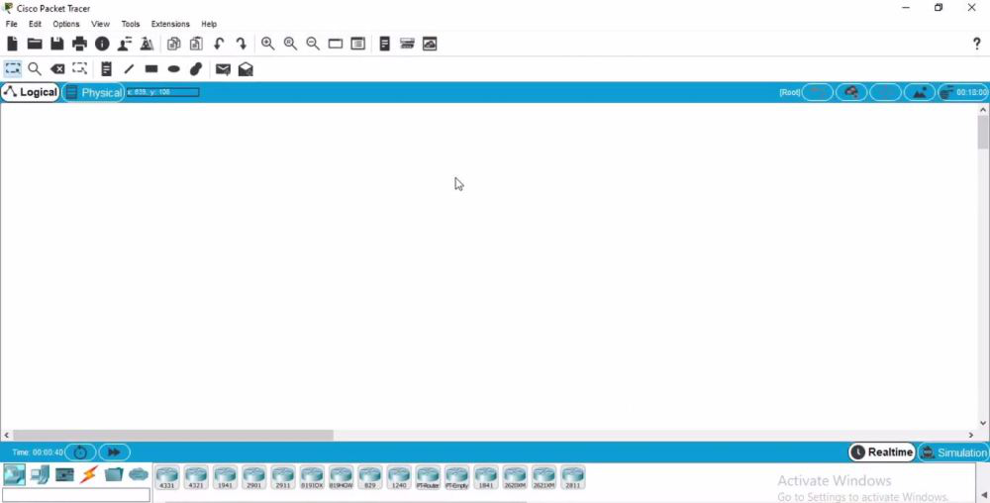

Congratulations you have successfully installed packet tracer on your Windows System.

**NEXT STEP TOWARDS THE PROJECT**

**STEP 1:-**Before start simulating the smart device there are some device that are required for us to start doing that one of the device HOME GATEWAY/WIRELESS ROUTER is needed.

**STEP 2:-**Gateway will provide Wi-Fi connection because these devices will be connecting them through wireless network so the ohm gate will be providing the wireless connection to the devices and it also will be providing registration server to these iot device remember we want to control these devices and we must access the console the Management console the platform the device that is giving the management concern .

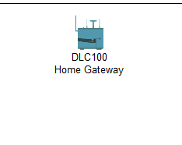

**STEP 3:**-Now add smart devices for example fire sprinkler for sprinkling water in case of fire, smoke detector in case there's fire, door, window, light celling fan,

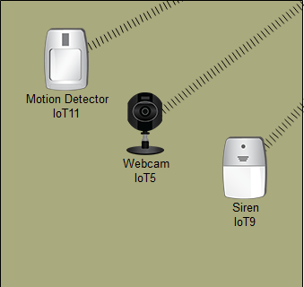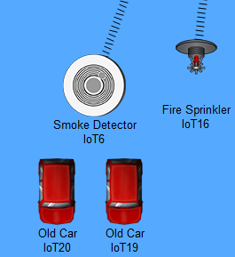

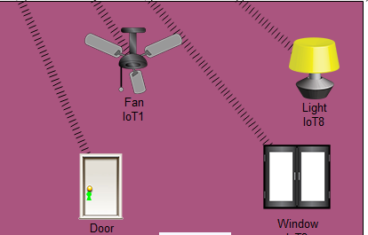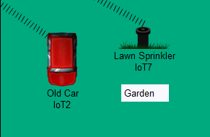

**Step 4:-**Old car which is not connected , so we have not enabled the Wi-Fi card there because it's not enabled by default so we need to do it manually so just go to physical I mean config just a minute just go to Advanced click then go to is config IO config then network adapter just choose the wireless network adapter just choose the wireless one PMT iot and M Wireless okay and that's done and also for this one you see now it's connected.

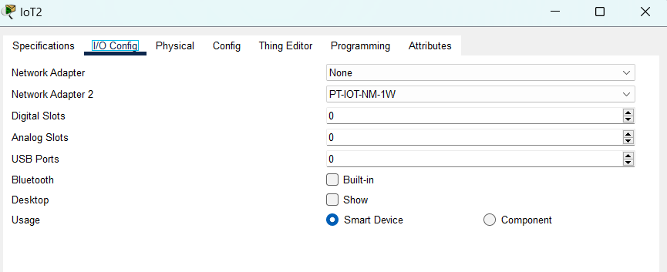

**STEP 5:**- the device here the home kit will provide a Management console for all

these devices so to provide a Management console we should have a device and an end device to monitor. The iot devices the end device can be any wireless device so for example I can choose my laptop, my tablet or my smartphone. Here, I am using a tablet so let's just give it time to connect to

the home Gateway if it doesn't connect I check the password and the username of Home Gateway remember the home Gateway mostly used for Iot so you just go to config then Wireless and you can see the name is home Gateway so I just go to tablet config and the Wi-Fi name is home Gateway just paste that and close and it will be connected and assigned an IP address so as you can see here it has been connected .

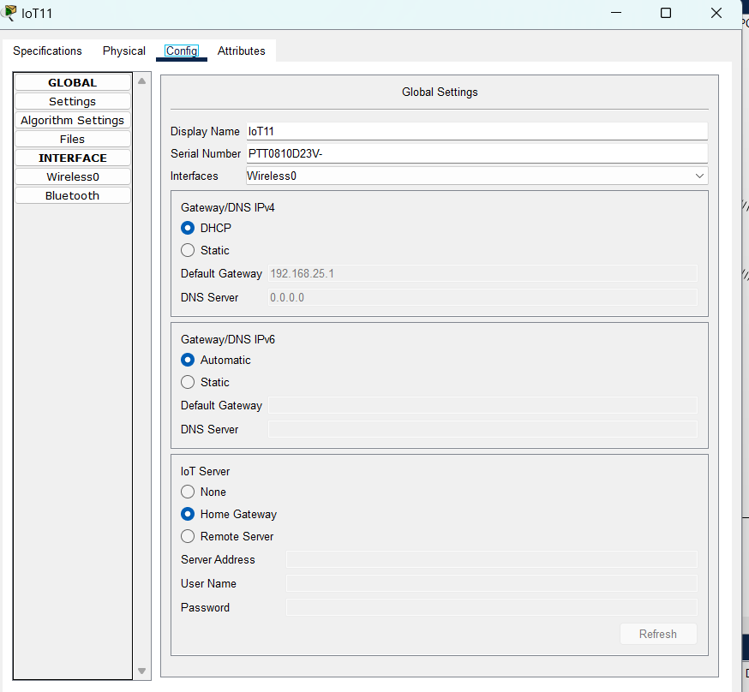

**STEP 6:-** access the Management console from our tablet we just click on the tablet and go to desktop and you go to iot monitor you just click on it monitor

and let's login let's login let's login give it some time so as for now you know we've logged in successfully but there's no there's no listed devices here why we've not registered the devices in the iot server so we just need to register each device on the IIT server let's start with this Smoke detector click on the order it's running then you come to config and you choose home Gateway and iot server let's register it to home Gateway this is our home Gateway it's now registered

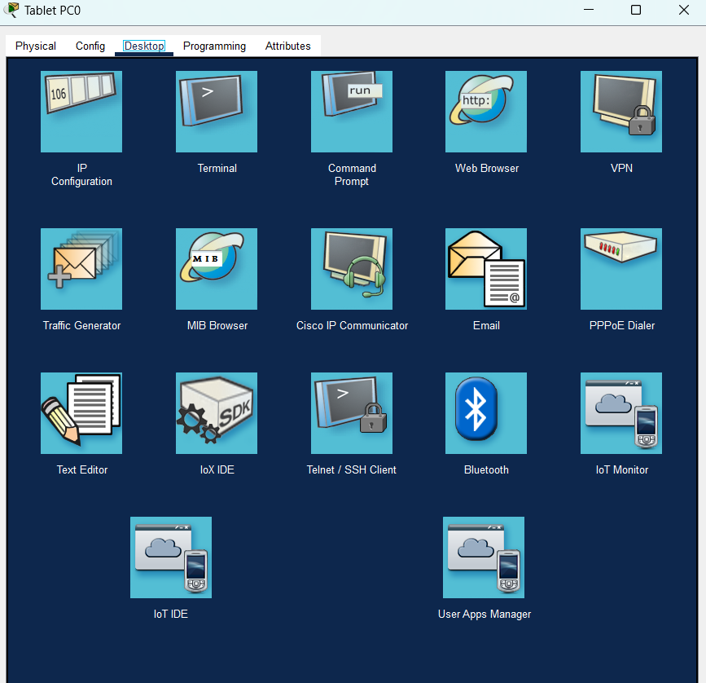

**STEP 7:-** Okay so we've registered all the devices to the home Gateway so we'll just go back to our tablet and see if they are now listed so I'll just log out shall we login again so you can see all the device are being listed here you can see all the device that you've registered are being listed listed here and from this phone from this tablet we can control all the devices.

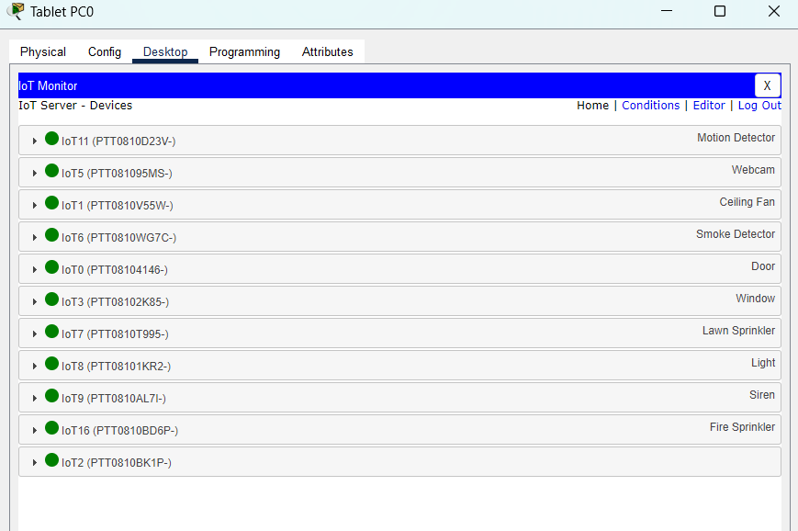

**STEP 8**:- Now we will going to apply the conditions on devices as per our requirements. For this go to tablet then in IOt monitor login and then go to condition here you can apply conditons on devices which you want to add .

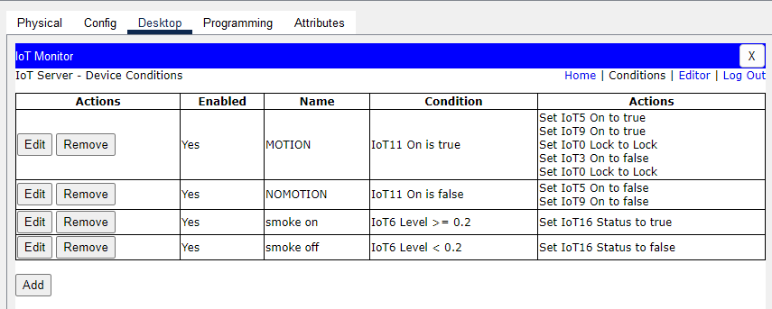

**STEP 9**:- Here our IOT based home design is ready to use.

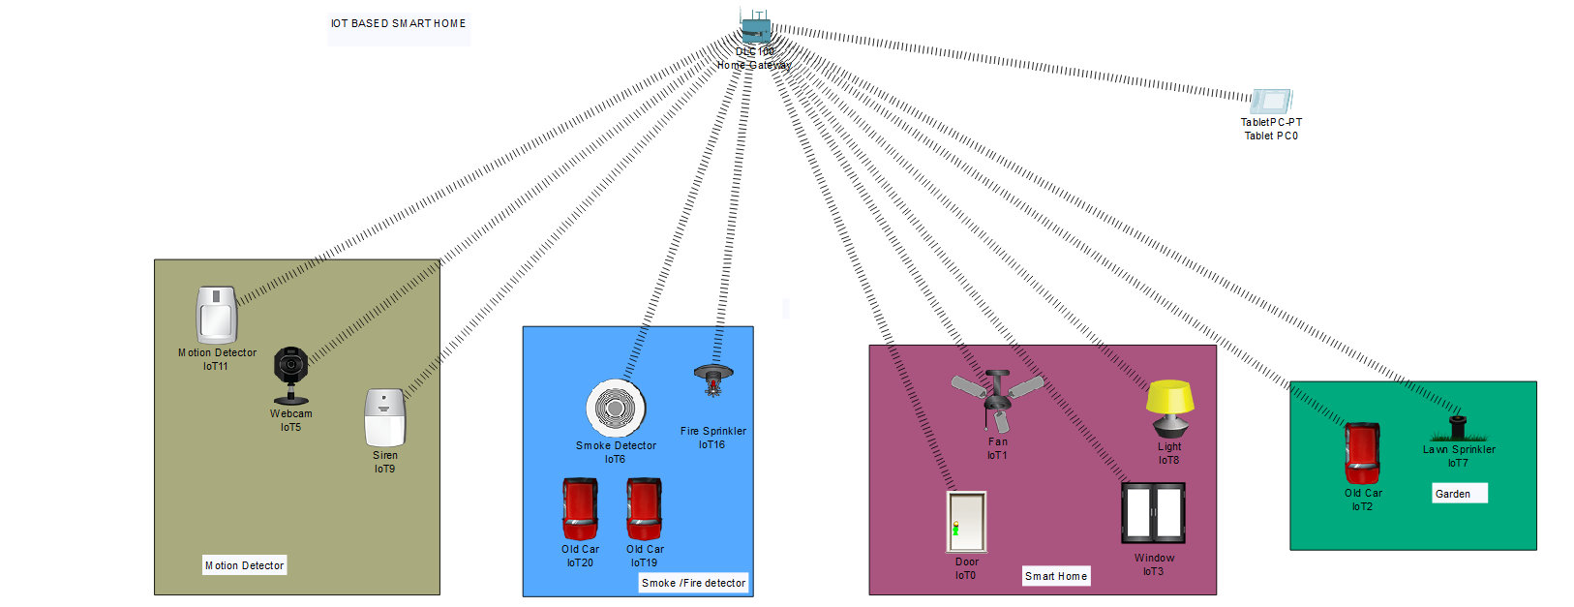

MOTION DETECTOR

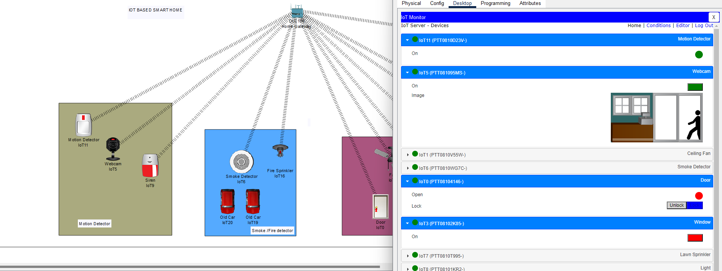

SMOKE DETECTOR

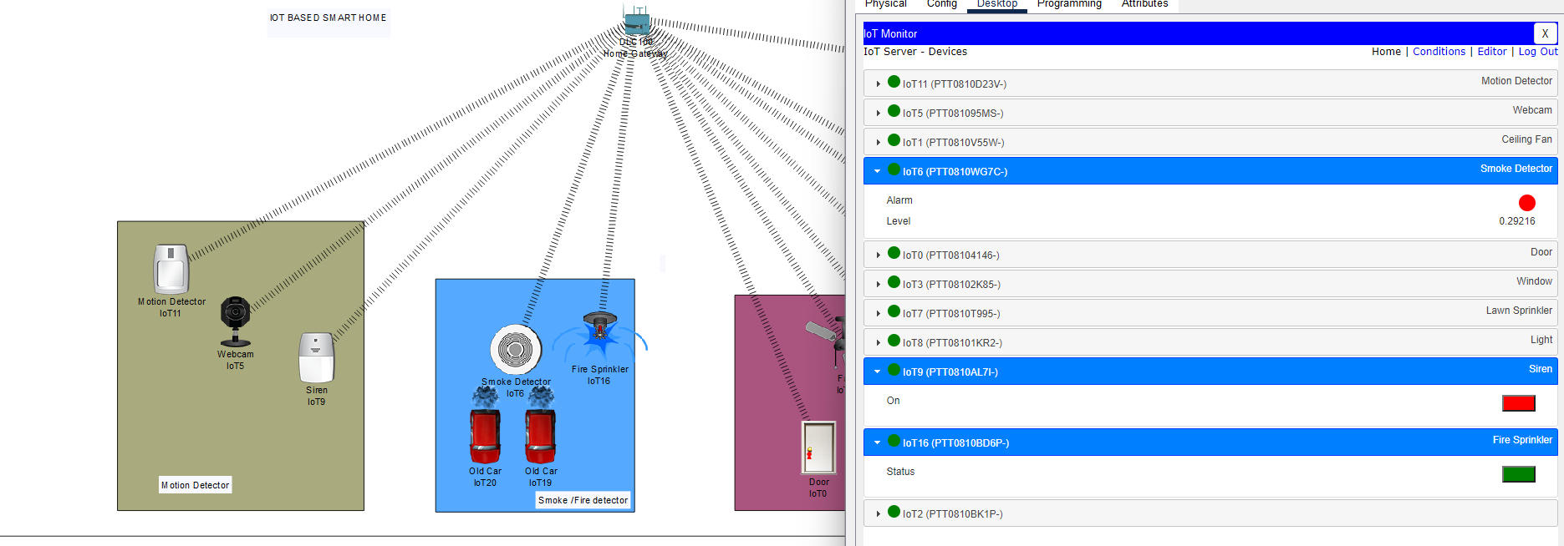

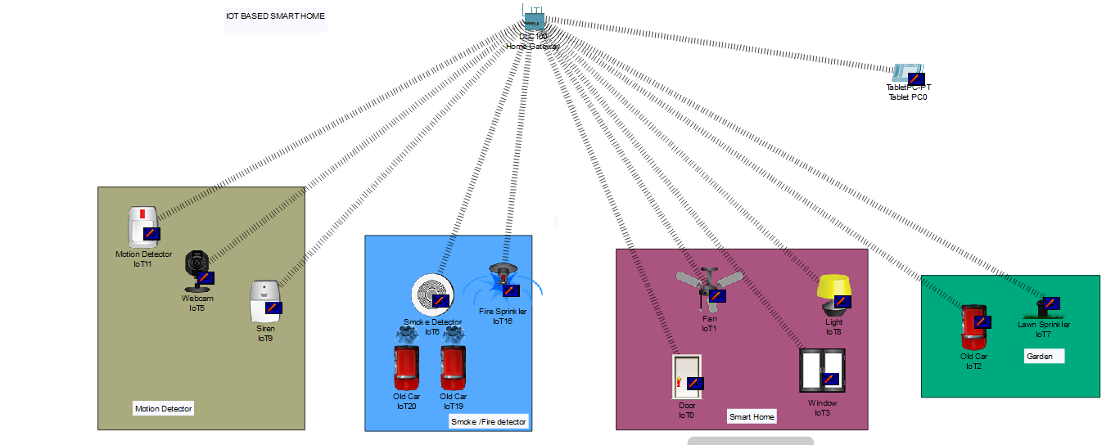

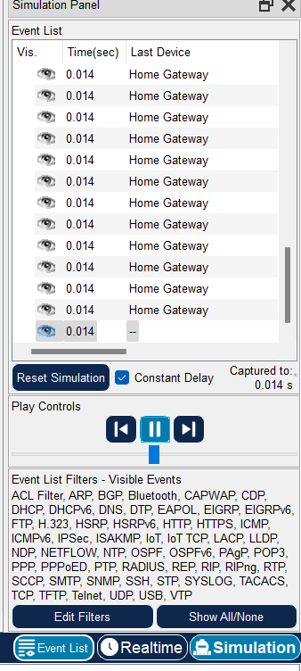

**CONCLUSION**

The IoT Device market has undergone radical changes in only a few short years. Starting with disparate devices and no ecosystems to speak of , the market has grown to encompass enterprise players working together to create ecosystem, tailored for mobile technology , which allow Iot devices to become interconnected.

Automation of the home may have once seemed like a peculiar and unlikely concept ,but as our devices become smarter and more investment is poured into the development of iot consumer products, we are likely to see increased competition on further innovation in the field.